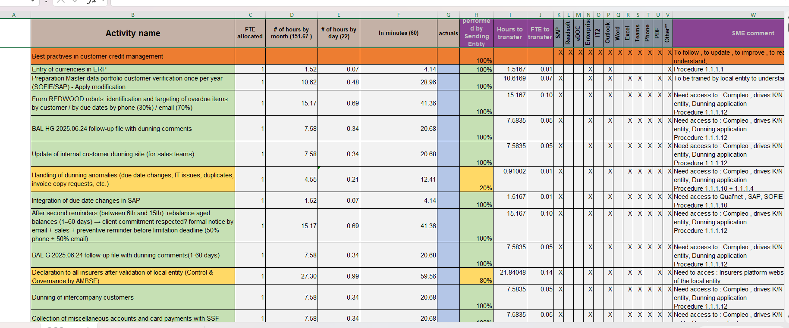
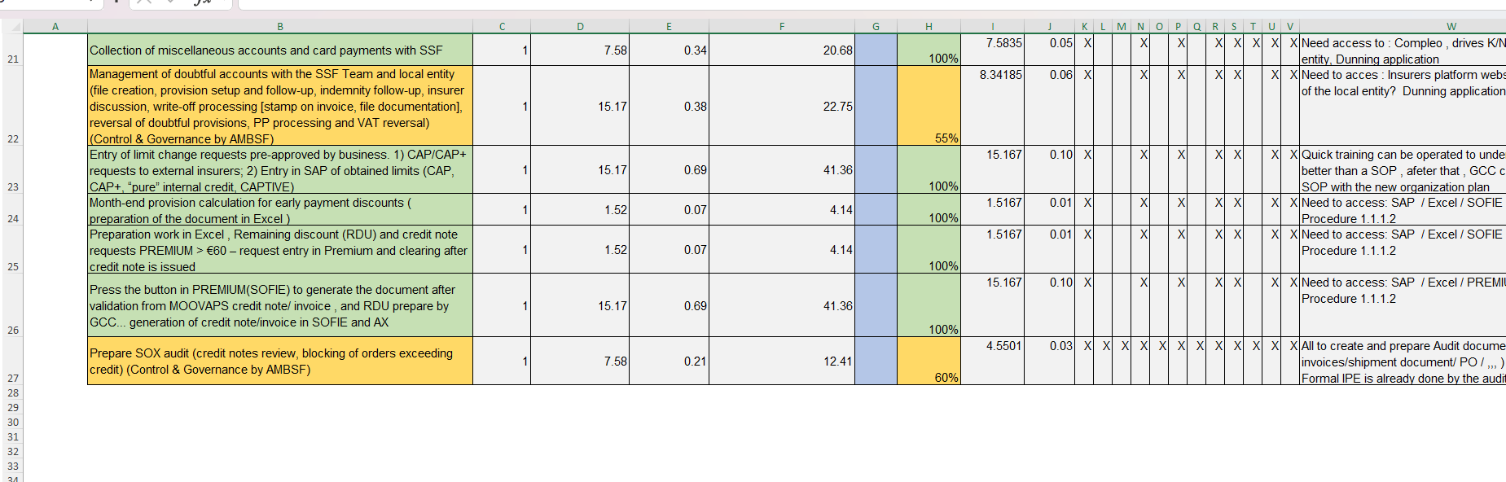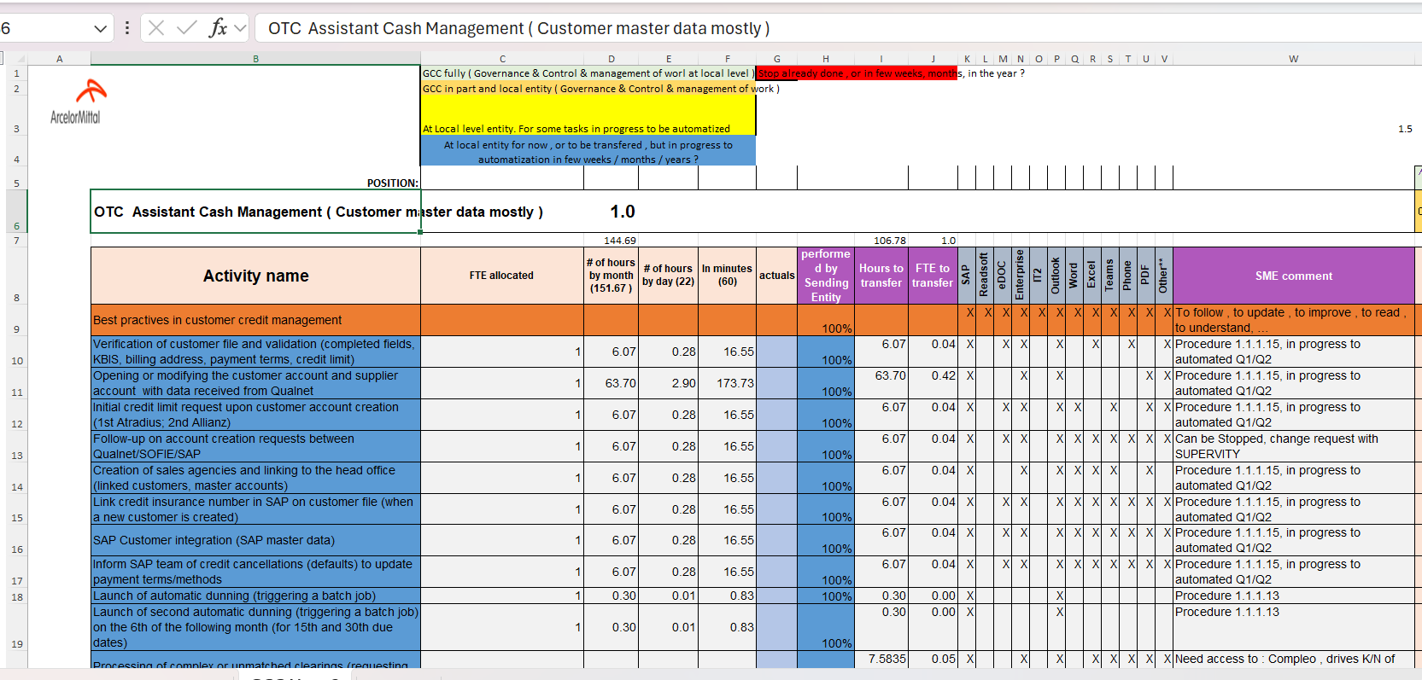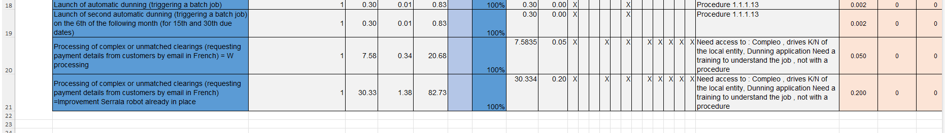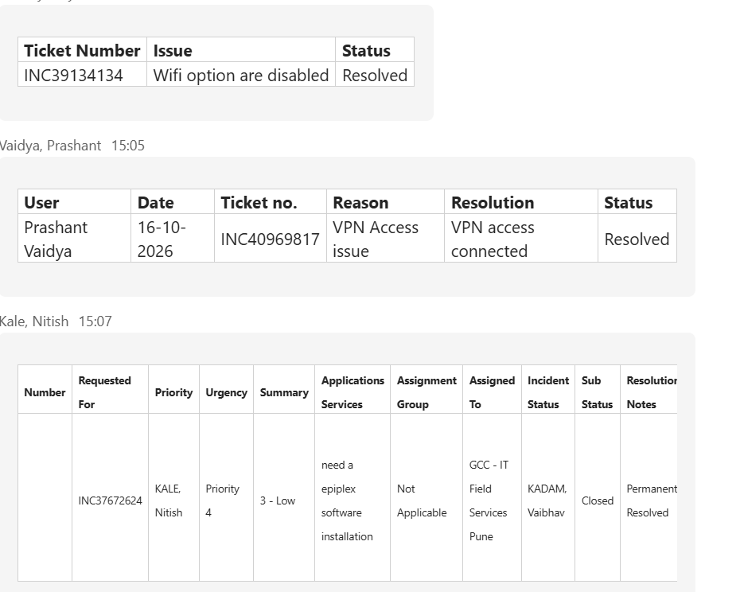What are the logic used for writing search words.
When and What are points that should consider creating duplicates.
How can we verify that sales are asking right or wrong.
Checklist of verifications before creating accounts.
While creating entity in existing account both siret are active then which should be taken – 1 the siret in existing account or 2 the siret requested .

I acknowledge that I entered partial address twice. She explained the scenarios and clarified which entity’s address should be entered, and when and where it should be entered in SAP. Just before one hour. We already edited that things in the sap, going Forword that silly mis will not be happen. For this I will verify twice all the verifications.
Going forward

